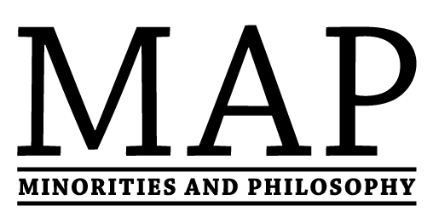
UK
Summer Report
Thursday, 22nd June 2017
UK MAP chapters met regularly throughout the first half of 2017, continuing to address and discuss MAP-related issues. They hosted a wide variety of events, and are also planning many more for the next academic year. The following report comprises some of the highlights of these activities.
News
- We are delighted that MAP UK presented in collaboration with MAP@Leeds at ‘The Profession We Want: Practical Ways to Improve Philosophy’ conference at the University of Manchester, on 15th May. Our talk was entitled ‘Minorities in Philosophy: Practical Lessons from a postgraduate initiative’.
- MAP UK are recruiting for a co-director! The deadline is the 31st July, and you can find all of the information here: http://mapuk.weebly.com/join-our-team.html
Events & Activities
- The Glasgow chapter hosted their annual workshop, this time focusing on Justice and Education: https://www.facebook.com/events/1072403679549616/. They also organised a talk for undergraduates on the topic of feminist theology, where Anna Ortín (Edinburgh) presented.
- The Leeds chapter has had three reading groups. Two were aimed at undergraduate students, focusing on issues of philosophy of gender and race. The other was on taste oppression and benefited immensely from the presence of the author, Anne Eaton (UIC). Leeds also had a workshop with Kengo Miyazono (Hiroshima), who gave a presentation on Implicit Bias. For more specific information, see MAP@Leeds’ website: http://mapleeds.weebly.com/schedule-at-a-glance.html
- The Leeds chapter hosted its second conference, entitled ‘Philosophical Perspectives on Disability: A Postgraduate Conference’. This had 5 postgraduate speakers and a keynote talk from Jackie Leach Scully (Newcastle). Here is a link to the conference website: http://ppod2017.weebly.com/
- The Southampton chapter hosted a lunch to discuss what their fellow students and staff would like to get out of this newly-formed chapter, as well as ideas for achieving these aims.
- The Warwick chapter organised an event on Indian Philosophy with Dr Christopher Bartley (Liverpool). They also hosted a workshop on the ‘Politics of Recognition’, with Prof Miguel Beistegui (Warwick). The latter was to spark discussion in light of the ‘Rhodes Must Fall’ movements in South Africa. Both events were well-attended (at least 20 students at each).
Good Practice, Training & Advocacy
- The KCL chapter has successfully formed a student society as a part of their union, which they hope will be particularly helpful for attracting new students.
- The KCL chapter has been meeting with their syllabus committee to discuss motivations and sources for better syllabus diversification.
- The Leeds chapter has made process with its access initiatives, and has started working with a local high school, helping them teach their first AS philosophy classes, as well as with a national self-help organisation for people who are no longer in employment (University of Third Age).
- The Leeds chapter has been providing small contributions to the attendance costs for University of Leeds students from under-represented groups attending philosophy conferences.
- The Southampton chapter has started to attend all faculty board meetings, and to meet with their Head of Department, to discuss (for instance) how to encourage diversity in undergraduate syllabi. They have also started a twitter account: https://twitter.com/MAPsouthampton

Mentorship Scheme
Our mentorship scheme now has 21 mentors from diverse social and philosophical backgrounds. They are prepared to offer email-based advice or mentoring to members of underrepresented groups on a range of topics, including: student life, the job market, and promotion. You can find more details on our website: http://mapuk.weebly.com/uk-mentors.html
If you think you might benefit from having a(n additional) mentor, or if you have any questions or feedback about the scheme, then please get in touch with us via our email address: mapforthegap.uk@gmail.com, or contact a mentor directly.

Thanks
We’d like to thank all of our new and existing chapters for their continued hard work and dedication in organising such a fantastic and varied programme of events. We’d like to thank everybody who participated in these events and activities, as well as all other supporters in our home departments and beyond, who have helped to make all of these activities possible. We’d also like to thank our ever-growing network of mentors, whose commitment to making Philosophy a more inclusive and supportive environment is invaluable. We wish everybody a wonderful summer!
For further information on MAP UK, or to make a suggestion, please contact us at mapforthegap.uk@gmail.com.
Apply to form a chapter, become a mentor, or find out more at http://mapuk.weebly.com. For more information on the MAP project globally, visit http://www.mapforthegap.com.

